题1



题2

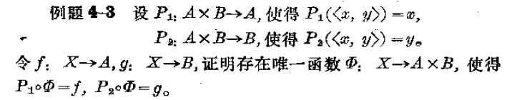

题3

4-3题4

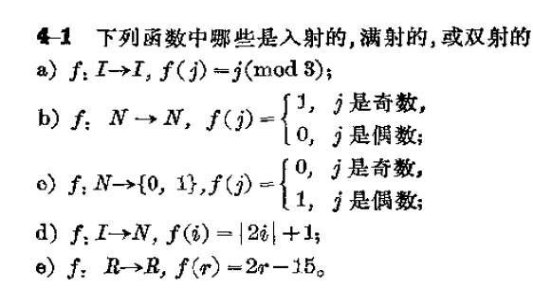题5

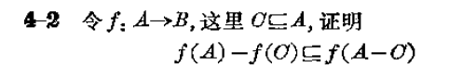

题6

4-8

题7

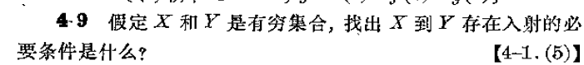题8

